University of Petroleum and Energy Studies



Session: 2024-2025

Semester: IV

BTech Computer Science

(OOPS – Lab-1)

Introduction to Java Environment

Submitted by Submitted to

Daksh Mehrotra Satyam Sir Batch: 56

Sap Id: 500125960

Roll no: R2142231932

Q1. Explore and understand the role of JDK, JRE and JVM.

### A1. **1. JVM (Java Virtual Machine):**

* **Role**: The JVM is the runtime environment that executes Java bytecode. It abstracts the underlying hardware and operating system, enabling Java's "write once, run anywhere" capability.
* **Key Responsibilities**:
  + Converts bytecode into machine-specific code using the Just-In-Time (JIT) compiler.
  + Handles memory management (via the garbage collector).
  + Ensures runtime error handling.
  + Provides a secure execution environment by verifying the bytecode.
* **Lifecycle**:
  + Class loader loads .class files (bytecode).
  + Bytecode is verified for security and correctness.
  + Bytecode is interpreted or compiled into native machine code for execution.

### **2. JRE (Java Runtime Environment)**

* **Role**: JRE provides the libraries and components required to run Java applications. It includes the JVM and supporting libraries but does not have development tools.
* **Components**:
  + **JVM**: Executes Java programs.
  + **Core Libraries**: Provide essential functionality like I/O, networking, and utilities.
  + **Other Runtime Components**: Includes classes for graphics, database connectivity, etc.
* **Use**: When you just want to run Java applications, you only need the JRE installed.

### **3. JDK (Java Development Kit):**

* **Role**: JDK is the full development kit needed for creating, compiling, and debugging Java programs. It includes the JRE, development tools, and additional resources.
* **Components**:
  + **JRE**: To run compiled Java applications.
  + **Development Tools**:
    - javac: Java compiler for converting source code (.java) into bytecode (.class).
    - java: Launcher tool to run Java applications.
    - javadoc: Documentation generator.
    - jdb: Debugger.
  + **Libraries**: APIs and class libraries necessary for development.
* **Use**: If you're developing Java programs, you need the JDK installed.

Q2. Install latest available JDK and verify the Java Environment.

A2. 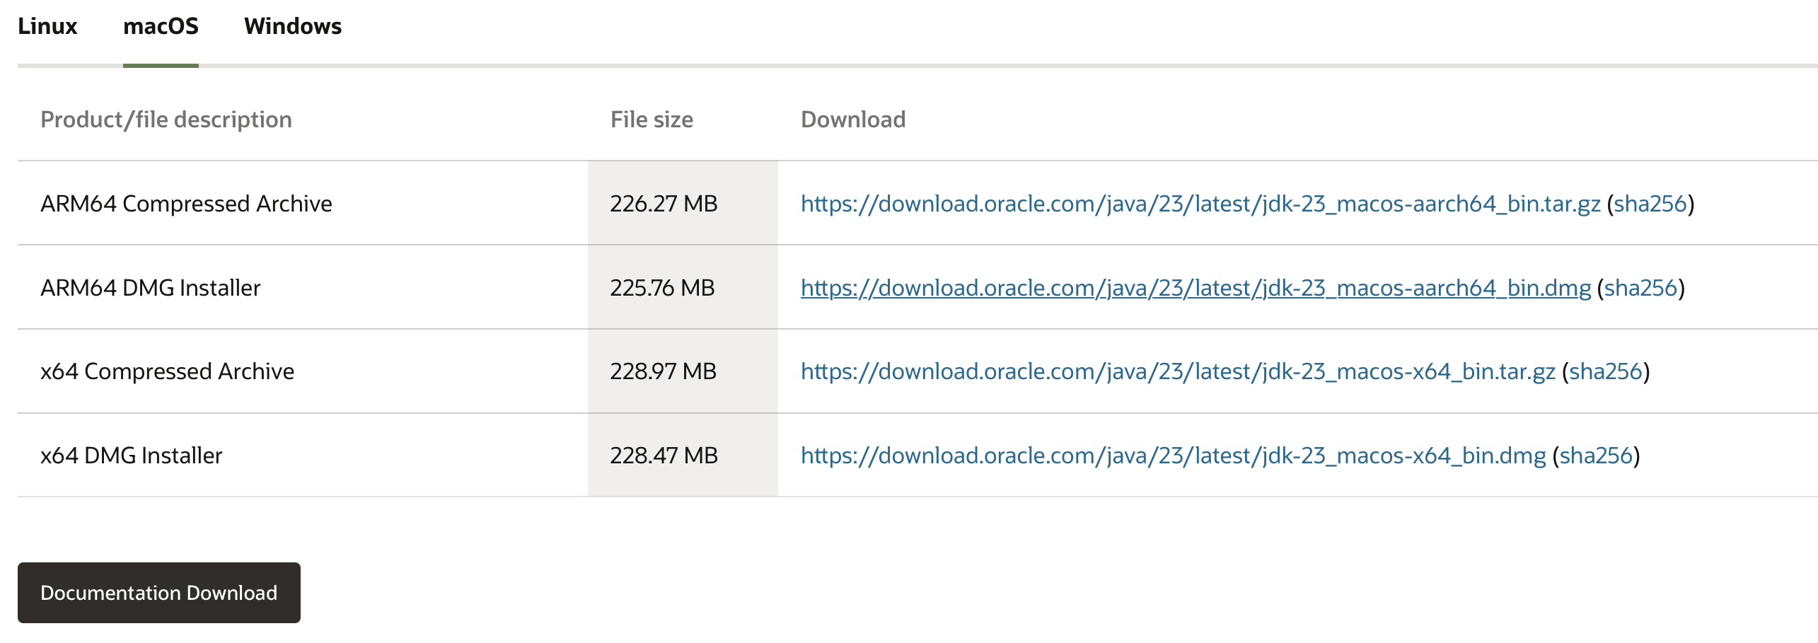

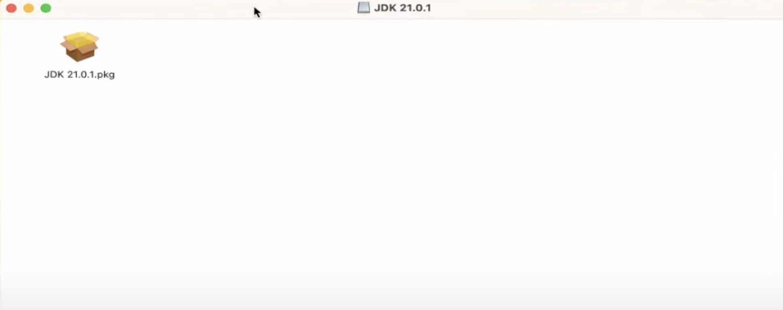

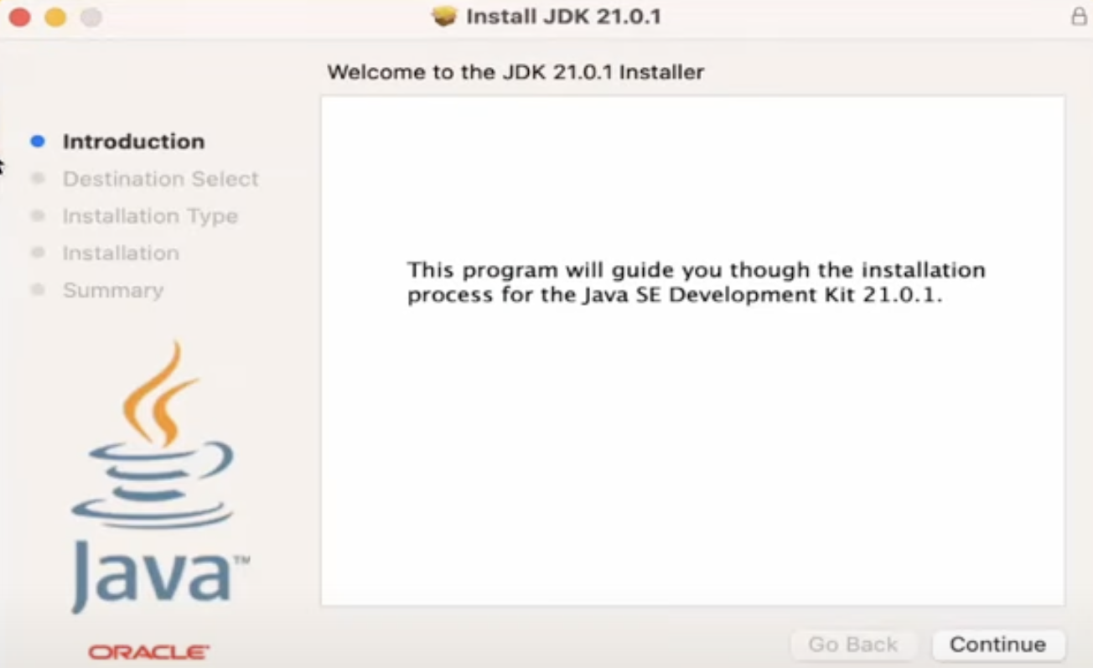

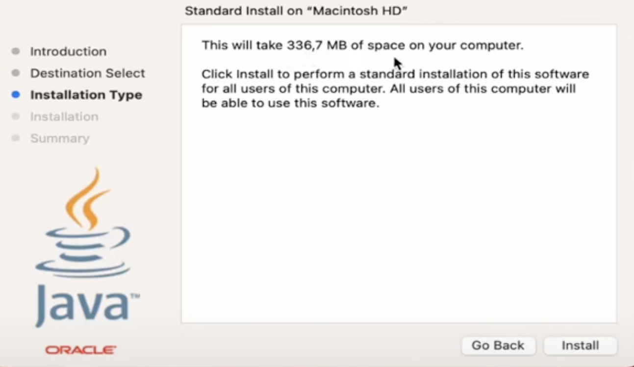

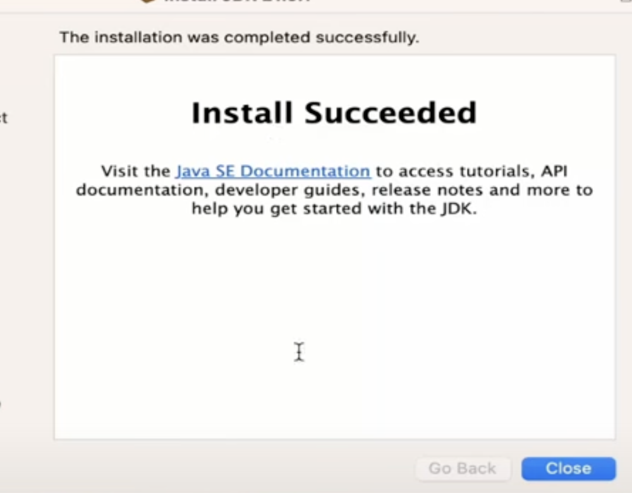

Q3. Create a Sample Hello World Program using simple text editor (e.g. Notepad) and show the steps to compile and execute the program using command prompt.

A3.

Step 1: Write the below code using a text editor or an online compiler: 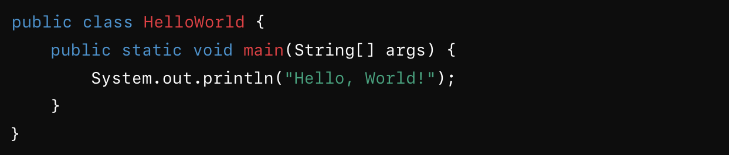

Step 2: Open Command Prompt

Navigate to the directory where the file is saved:



Step 3: Compile the Program



Step 4: Execute the Program

Output:



Q4. Display your name and complete address in different lines.

A4. The code for the above is as follows:

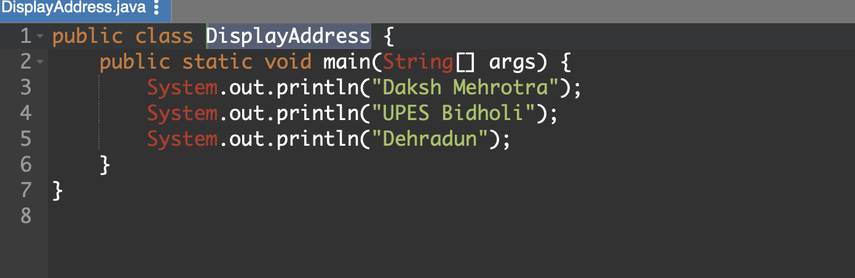

Output:

